WATER LOGGING PREVENTION AND DETECTION

S Sowjanya   
Computer Science and Engineering  
MLR Institute of TechnologyHyderabad, India  
[soujanyastar161297@gmail.com](mailto:soujanyastar161297@gmail.com)

P Sai Pavan Reddy  
Computer Science and Engineering  
MLR Institute of TechnologyHyderabad, India  
[pavanreddy2491@gmail.com](mailto:pavanreddy2491@gmail.com)

M Nikitha Reddy  
Computer Science and Engineering  
MLR Institute of TechnologyHyderabad, India  
[nikithareddy.m97@gmail.com](mailto:nikithareddy.m97@gmail.com)

Dabbakuti Harsha Vardhan  
Computer Science and Engineering  
MLR Institute of TechnologyHyderabad, India  
[hv161297@gmail.com](mailto:hv161297@gmail.com)

Bharath Sai Hari  
Computer Science and Engineering  
MLR Institute Of TechnologyHyderabad, India  
[bharathsai.hari@gmail.com](mailto:bharathsai.hari@gmail.com)

G Divya Jyothi  
Computer Science and Engineering  
MLR Institute of TechnologyHyderabad, India  
[divyag.1605@gmail.com](mailto:divyag.1605@gmail.com)

**Abstract:** In present times water logging has become one of the biggest problem in traffic management. Due to poor planning during the construction of roads this problem has been affecting many people of the society. Even after this problem is recognized by the government, no proper measurement were taken.

This project is used to overcome the problem of water logging in cities during rains. It is a combination of IOT and web application.We collect the level of water logging on a particular road using sensors, then according to this data, pump will get triggered and send the rain water to near by water reservoir for purification.This data will also be used to create a map application in which user can check out the details of water logging from any place and avoid the traffic.

**Keywords: purification ,water logging, water reservoir**

**I.INTRODUCTION:**

**1.1OVERVIEW**

People travels on the roads, in rainy seasons the roads are blocked with traffic because rain water logging on roads and manholes are full with water .So to overcome these problems our project will help to prevent these problems we are using sensor at manhole when manholes are filled with rain water then the rain water goes to reservoirs through underground pipe lines at the nearest lakes rivers etc.. and by taking all these we pass information to the people in google maps in which area traffic is more by that information they can decide their way to reach their destination.

**1.2 PURPOSE OF THE PROJECT**

The purpose of this project to reduce traffics on roads and to keep the roads clean and also to convey the traffic information to people.

**II.LITERATURE SURVEY**

We conducted a thorough literature survey by reviewing existing systems for detecting fake and clone accounts. Research papers, journals and publications have also been referred in order to prepare this survey.

**III.EXISTING SYSTEM**

There is no proper system or solution for this problem. This project would be the first solution for this problem

Concisely summarizing the disadvantages of the above implementations:

In present scenario due to heavy rainfalls, roads are blocked. This water is sent directly into manholes and all of this water is getting wasted.

As there are no proper measures taken to prevent this problem roads are blocked and it causes heavy traffic jams.

In current situation water logging detection on map is done by satellite imaging which is a big process.

Even in satellite imaging it can only detect a large amount of water logging like floods etc , small water loggings on city roads cannot be detected.

**IV.PROPOSED SYSTEM**

We can overcome this problem using IOT. We use components like Arduino UNO, ultrasonic sensor, pump etc.Using the above data we provide a mapping application for the user to know locations of water logging from any place.This project uses IOT to detect even small water loggings(like city roads etc.) and time consumption is less.

**OBJECTIVES OF PROPOSED SYSTEM**

The objectives of the proposed system include the following:

i.To reduce traffic.

ii.To reduce water logging on roads in rainy season.

iii.To give information to people about traffic.

iv.To show the information of traffic in maps using HTML,CSS.

**V.IMPLEMENTATION**

The implementation of the proposed system model is quite simple if you follow the given steps. Firstly we need to install the Arduino software from the internet. As this will help you in dumping the code to the microprocessor. Here, we are using Arduino UNO(Atmega 328) as the microprocessor.

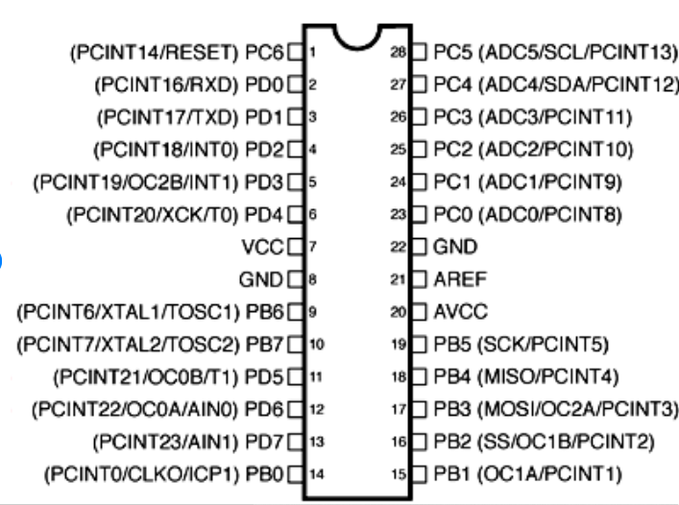

Fig:1 Pin diagram of Arduino UNO

Fig:2 Arduino software

Secondly, ultrasonic sensor,ESP8266 , pump and relay are connected to Arduino UNO and trigger the pump when a certain water level is reached.

This water level data is sent to “thingspeak” server using ESP-01 by their API.

A mapping application is developed to show the water logging location to the user.

This is achieved by making a GET request to “thingspeak” server and getting the data sent by the Arduino and place markers on the map accordingly.

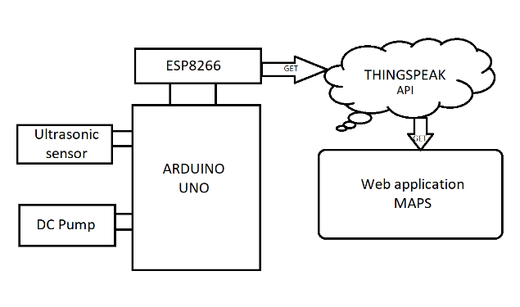

Fig 3: Block diagram of the model

**VI.RESULT**

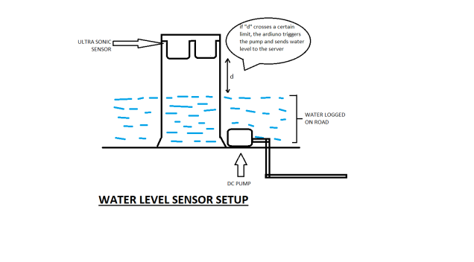Fig 4:realtime connection of this project

In this way we are connected the circuit by this we can detect the water level and send it to sensor and then after to pumps and to reserviours though pipelines.

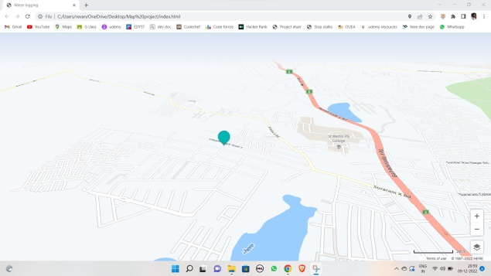 Fig 5:To show traffic in maps

To shows maps we are using thingspeaker to built map api

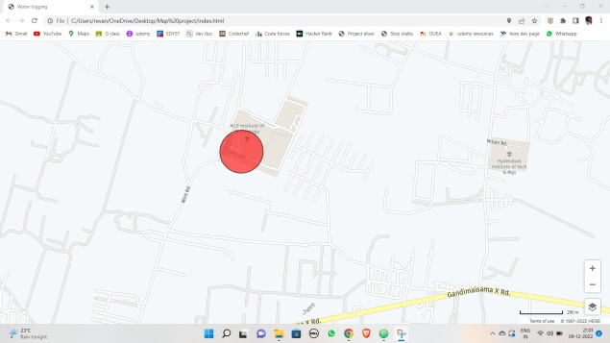

Fig 6:location pointing

**VII .CONCLUSION**

People from inclined areas, rural areas, are most affected from this problem. So this will be very

This project will be very useful to reduces the water logging and traffic jams.In this we have learned about web technologies , IOT, REST API.

**ACKNOWLEDGEMENT**

The satisfaction and euphoria that accompany the successful completion of any task would be incomplete without the mention of people who made it possible, whose constant guidance and encouragement crowned our efforts with success. It is a pleasant aspect that we now have the opportunity to express our guidance for all of them.

First of all, we would like to express our deep gratitude towards our internal guide **Dr. E.ANUPRIYA, Assistant Professor ,HOD , Department of CSE** for her support in the completion of our dissertation. We wish to express our sincere thanks to **Dr. E. ANUPRIYA,** HOD, Dept. of CSE for providing the facilities to complete the dissertation.

We would like to thank all our faculty and friends for their help and constructive criticism during the project period. Finally, we are very much indebted to our parents for their moral support and encouragement to achieve goals.

**REFERENCES**

<https://developer.here.com/documentation/>

<https://thingspeak.com/login?skipSSOCheck=true>

<https://docs.arduino.cc/hardware/uno-rev3>